In [1]:
import pandas as pd
import seaborn as sns
1 | df = pd.read_csv("diabetes.csv")
2 | df

In [5]:
Out[5]: |  | Pregnancies | Glucose | BloodPressure | SkinThickness | Insulin | BMI | Pedigree | Age | Out
 | 0 | 6 | 148 | 72 | 35 | 0 | 33.6 | 0.627 | 50
 | 1 | 1 | 85 | 66 | 29 | 0 | 26.6 | 0.351 | 31
 | 2 | 8 | 183 | 64 | 0 | 0 | 23.3 | 0.672 | 32
 | 3 | 1 | 89 | 66 | 23 | 94 | 28.1 | 0.167 | 21
 | 4 | 0 | 137 | 40 | 35 | 168 | 43.1 | 2.288 | 33
 | ... | ... | ... | ... | ... | ... | ... | ... | ...
 | 763 | 10 | 101 | 76 | 48 | 180 | 32.9 | 0.171 | 63
 | 764 | 2 | 122 | 70 | 27 | 0 | 36.8 | 0.340 | 27
 | 765 | 5 | 121 | 72 | 23 | 112 | 26.2 | 0.245 | 30
 | 766 | 1 | 126 | 60 | 0 | 0 | 30.1 | 0.349 | 47
 | 767 | 1 | 93 | 70 | 31 | 0 | 30.4 | 0.315 | 23

768 rows × 9 columns

In [7]:
1 | x = df.drop('Outcome', axis = 1)
2 | y = df['Outcome']

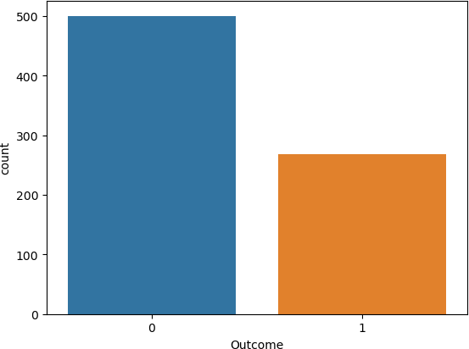
In [8]:
sns.countplot(x=y);
1

In [9]:
y.value_counts()
1

Out[9]: 0 500
1 268
Name: Outcome, dtype: int64

In [11]:
1 | from sklearn.preprocessing import MinMaxScaler
2 | scaler = MinMaxScaler()
3 | x_scaled = scaler.fit_transform(x)

In [14]:
1 | from sklearn.model_selection import train_test_split
2 | x_train,x_test,y_train,y_test = train_test_split(x_scaled,y,random_sta

In [15]:
(768, 8)
(576, 8)
x_test.shape
1
x_train.shape
1
x.shape
1

Out[15]:

In [16]:

Out[16]:

In [17]:

Out[17]: (192, 8)

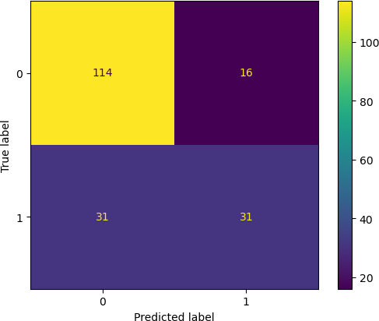
In [18]:
from sklearn.neighbors import KNeighborsClassifier
1

In [19]:
knn = KNeighborsClassifier(n_neighbors = 5)
1

In [20]:
knn.fit(x_train, y_train)
1

Out[20]: KNeighborsClassifier() In [23]:
1 | from sklearn.metrics import accuracy_score , ConfusionMatrixDisplay
2 | from sklearn.metrics import classification_report

In [24]:
y_pred = knn.predict(x_test)
1

C:\ProgramData\Anaconda3\lib\site-packages\sklearn\neighbors\_classificati on.py:228: FutureWarning: Unlike other reduction functions (e.g. `skew`, ` kurtosis`), the default behavior of `mode` typically preserves the axis it acts along. In SciPy 1.11.0, this behavior will change: the default value of `keepdims` will become False, the `axis` over which the statistic is ta ken will be eliminated, and the value None will no longer be accepted. Set
`keepdims` to True or False to avoid this warning. mode, _ = stats.mode(_y[neigh_ind, k], axis=1)

In [26]:
ConfusionMatrixDisplay.from_predictions(y_test,y_pred)
1

Out[26]: <sklearn.metrics._plot.confusion_matrix.ConfusionMatrixDisplay at 0x24c112 54f10>

In [27]:
print(classification_report(y_test,y_pred))
1

 | precision | recall | f1-score | support
0 | 0.79 | 0.88 | 0.83 | 130
1 | 0.66 | 0.50 | 0.57 | 62
accuracy |  |  | 0.76 | 192
macro avg | 0.72 | 0.69 | 0.70 | 192
weighted avg | 0.75 | 0.76 | 0.75 | 192

In [33]:
1 | import matplotlib.pyplot as plt
2 | import numpy as np



In [36]:

statistic is taken will be eliminated, and the value None will no longe r be accepted. Set `keepdims` to True or False to avoid this warning.
mode, _ = stats.mode(_y[neigh_ind, k], axis=1)
C:\ProgramData\Anaconda3\lib\site-packages\sklearn\neighbors\_classific ation.py:228: FutureWarning: Unlike other reduction functions (e.g. `sk ew`, `kurtosis`), the default behavior of `mode` typically preserves th e axis it acts along. In SciPy 1.11.0, this behavior will change: the d efault value of `keepdims` will become False, the `axis` over which the statistic is taken will be eliminated, and the value None will no longe r be accepted. Set `keepdims` to True or False to avoid this warning.
mode, _ = stats.mode(_y[neigh_ind, k], axis=1)
C:\ProgramData\Anaconda3\lib\site-packages\sklearn\neighbors\_classific ation.py:228: FutureWarning: Unlike other reduction functions (e.g. `sk ew`, `kurtosis`), the default behavior of `mode` typically preserves th e axis it acts along. In SciPy 1.11.0, this behavior will change: the d efault value of `keepdims` will become False, the `axis` over which the statistic is taken will be eliminated, and the value None will no longe r be accepted. Set `keepdims` to True or False to avoid this warning.
mode, _ = stats.mode(_y[neigh_ind, k], axis=1)
C:\ProgramData\Anaconda3\lib\site-packages\sklearn\neighbors\_classific
error = []
for k in range (1,41):
knn = KNeighborsClassifier(n_neighbors = k) knn.fit(x_train, y_train)
pred=knn.predict(x_test)
error.append(np.mean(pred!=y_test))
1
2
3
4
5
6

In [38]:
1 | plt.figure(figsize=(16,9))
2 | plt.xlabel('Value of K')
3 | plt.ylabel('Error')
4 | plt.grid()
5 | plt.xticks(range(1,41))
6 | plt.plot(range(1,41),error,marker='.')

Out[38]: [<matplotlib.lines.Line2D at 0x24c115ed8e0>]

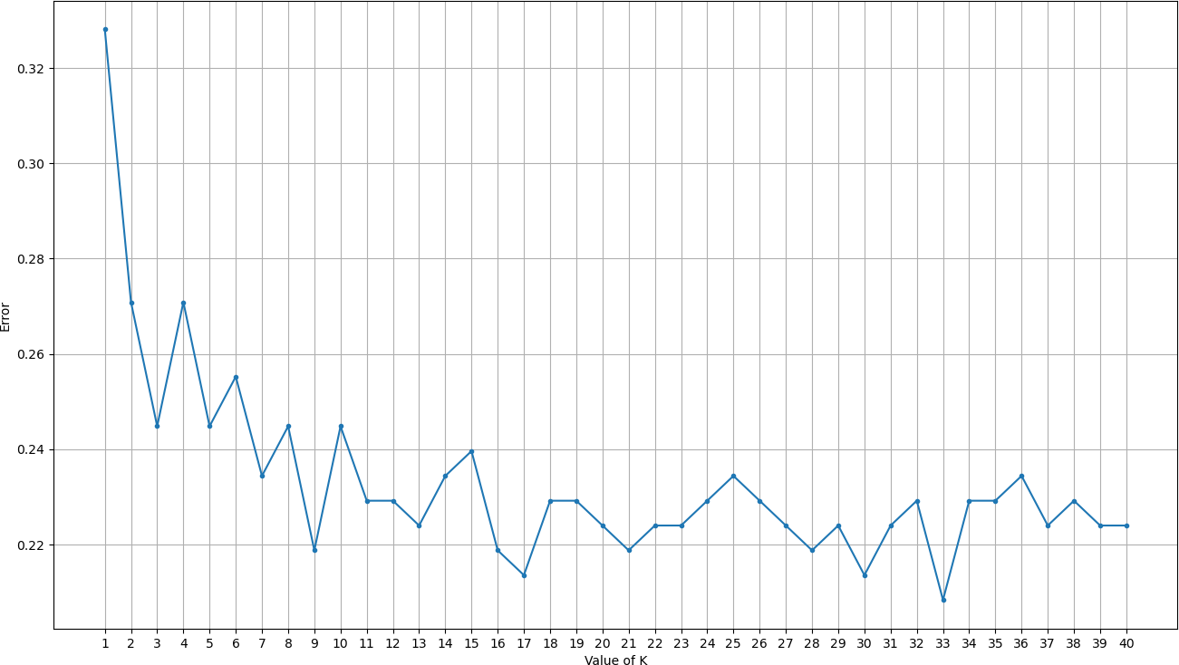
In [39]:
KNeighborsClassifier(n_neighbors=33)
C:\ProgramData\Anaconda3\lib\site-packages\sklearn\neighbors\_classificati
on.py:228: FutureWarning: Unlike other reduction functions (e.g. `skew`, ` kurtosis`), the default behavior of `mode` typically preserves the axis it acts along. In SciPy 1.11.0, this behavior will change: the default value of `keepdims` will become False, the `axis` over which the statistic is ta ken will be eliminated, and the value None will no longer be accepted. Set
`keepdims` to True or False to avoid this warning. mode, _ = stats.mode(_y[neigh_ind, k], axis=1)
print(classification_report(y_test,y_pred))
1
y_pred=knn.predict(x_test)
1
knn.fit(x_train, y_train)
1
knn = KNeighborsClassifier(n_neighbors = 33)
1

In [40]:

Out[40]:

In [41]:

In [42]:

 | precision | recall | f1-score | support
0 | 0.79 | 0.94 | 0.86 | 130
1 | 0.79 | 0.48 | 0.60 | 62
accuracy |  |  | 0.79 | 192
macro avg | 0.79 | 0.71 | 0.73 | 192
weighted avg | 0.79 | 0.79 | 0.78 | 192

In [ ]:
1

